|  |  |  |  |  |  |  |  |  |  |
| --- | --- | --- | --- | --- | --- | --- | --- | --- | --- |
| **SCHOOL OF COMPUTER SCIENCE AND ARTIFICIAL INTELLIGENCE** | | | | | **DEPARTMENT OF COMPUTER SCIENCE ENGINEERING** | | | | |
| **ProgramName:B. Tech** | | | | **Assignment Type: Lab** | | | **AcademicYear:2025-2026** | | |
| **Course Coordinator Name** | | | | **Venkataramana Veeramsetty** | | | | | |
| **Instructor(s)Name** | | | | |  | | --- | | **Dr. V. Venkataramana (Co-ordinator)** | | **Dr. T. Sampath Kumar** | | **Dr. Pramoda Patro** | | **Dr. Brij Kishor Tiwari** | | **Dr.J.Ravichander** | | **Dr. Mohammand Ali Shaik** | | **Dr. Anirodh Kumar** | | **Mr. S.Naresh Kumar** | | **Dr. RAJESH VELPULA** | | **Mr. Kundhan Kumar** | | **Ms. Ch.Rajitha** | | **Mr. M Prakash** | | **Mr. B.Raju** | | **Intern 1 (Dharma teja)** | | **Intern 2 (Sai Prasad)** | | **Intern 3 (Sowmya)** | | **NS_2 ( Mounika)** | | | | | | |
| **CourseCode** | | | **24CS002PC215** | **CourseTitle** | | **AI Assisted Coding** | | | |
| **Year/Sem** | | | **II/I** | **Regulation** | | **R24** | | | |
| **Date and Day**  **of Assignment** | | | **Week1 - Thursday** | **Time(s)** | |  | | | |
| **Duration** | | | **2 Hours** | **Applicableto**  **Batches** | | **24CSBTB01 To 24CSBTB39** | | | |
| **AssignmentNumber:1.4(Present assignment number)/24(Total number of assignments)** | | | | | | | | | |
|  | | | | | | | | | |
|  | **Q.No.** | **Question** | | | | | | ***ExpectedTime***  ***to complete*** |  |
|  | **1** | **Lab 1: Environment Setup – GitHub Copilot and VS Code Integration**  **Lab Objectives:**   * **To install and configure GitHub Copilot in Visual Studio Code.** * **To explore AI-assisted code generation using GitHub Copilot.** * **To analyze the accuracy and effectiveness of Copilot's code suggestions.** * **To understand prompt-based programming using comments and code context**   **Lab Outcomes (LOs):**  **After completing this lab, students will be able to:**   * **Set up GitHub Copilot in VS Code successfully.** * **Use inline comments and context to generate code with Copilot.** * **Evaluate AI-generated code for correctness and readability.** * **Compare code suggestions based on different prompts and programming styles.**   **Task Description #1 • Install and configure GitHub Copilot in VS Code. Take screenshots of each step.**  **Expected Output #1 • Successfully install and activate GitHub Copilot in VS Code. Include screenshots showing installation, authentication via GitHub, and an example suggestion from Copilot.**  **Task Description #2 • A function in Python that returns the maximum of three numbers using GitHub Copilot. Use an appropriate comment as a prompt.**  **Expected Output #2 • Python function that takes three inputs and returns the largest value. Include the code and output.**  **Task Description #3 • Use GitHub Copilot to create a recursive Python function that calculates the factorial of a number.**  **Expected Output #3 • Python function for factorial using recursion with input and output examples.**  **Task Description #4 • Prompt GitHub Copilot to create a class named Student with attributes name, roll_no, and marks. Add a method to display student details.**  **Expected Output #4 • Python class definition with an initializer and a display method. Include object creation and output.**  **Task Description #5 • Ask GitHub Copilot to generate a Python function that takes a string as input and returns the frequency of each word.**  **Expected Output #5 • Python function that returns word frequency using a dictionary. Provide sample input and output.**  **Note: Report should be submitted a word document for all tasks in a single document with prompts, comments & code explanation, and output and if required, screenshots**  **Evaluation Criteria:**   |  |  | | --- | --- | | **Criteria** | **Max Marks** | | **Install and configure GitHub Copilot in VS Code (Task #1)** | **0.5** | | **Python function that takes three inputs and returns the largest value (Task #2)** | **0.5** | | **Python function for factorial using recursion (Task #3)** | **0.5** | | **Python class definition with an initializer and a display method (Task #4)** | **0.5** | | **Function that returns word frequency using a dictionary (Task #5)** | **0.5** | | **Total** | **2.5 Marks** | | | | | | | **Week1 - Thursday** |  |

**Task Description #2  
•** A function in Python that returns the maximum of three numbers using GitHub Copilot. Use an appropriate comment as a prompt.

Prompt :

Write a python function that takes 3 integers as input from user and give the output as the maximum number among them .

Code:

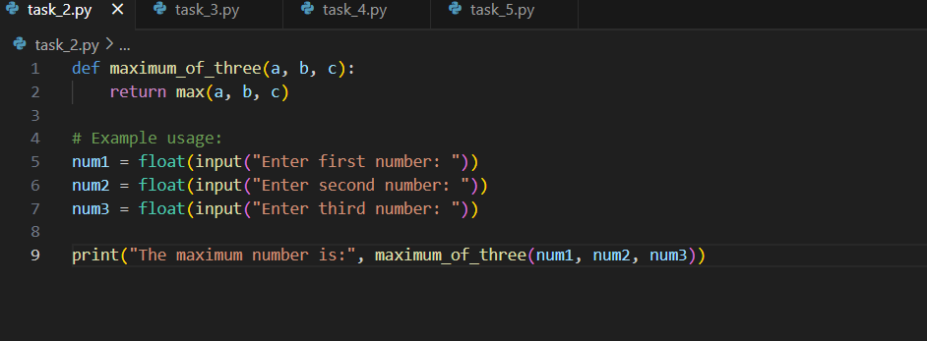

Output:

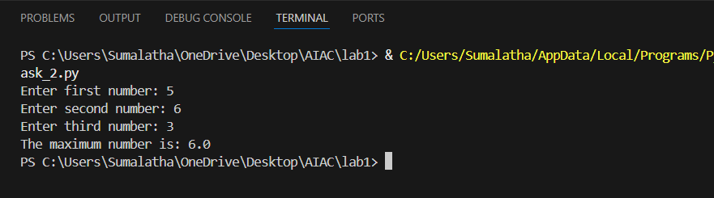

**Task Description #3  
•** Use GitHub Copilot to create a recursive Python function that calculates the factorial of a number.

Prompt:

Write a python function with recurstion that takes the input number from the user and give the factorial as the output of the given number .

Code:

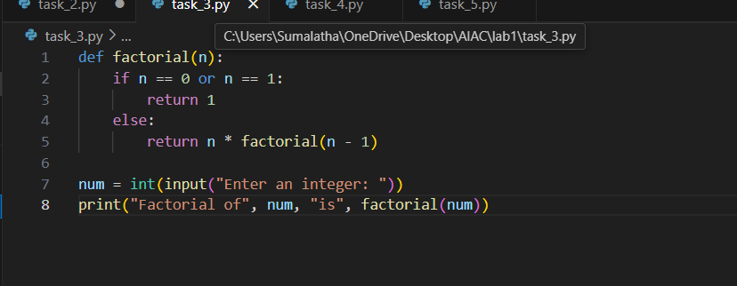

Output:

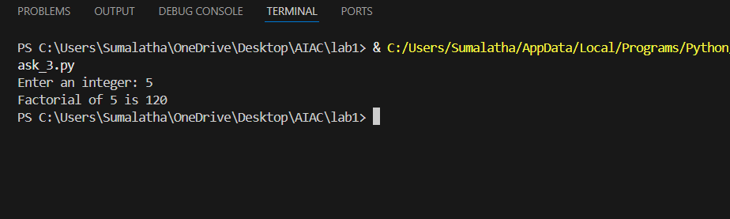

**Task Description #4  
•** Prompt GitHub Copilot to create a class named Student with attributes name, roll_no, and marks. Add a method to display student details.

Prompt:

Write a python function that create a class by taking the input as name ,roll no and marks of a student and also print that information as output .

Code:

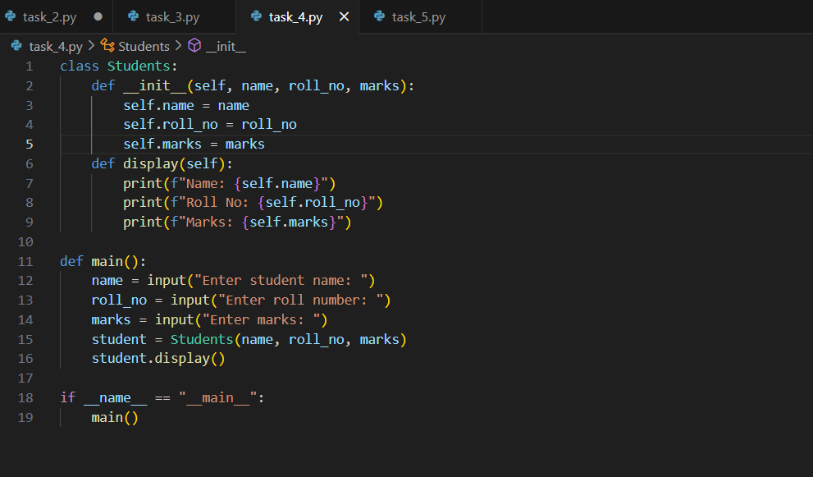

Output:

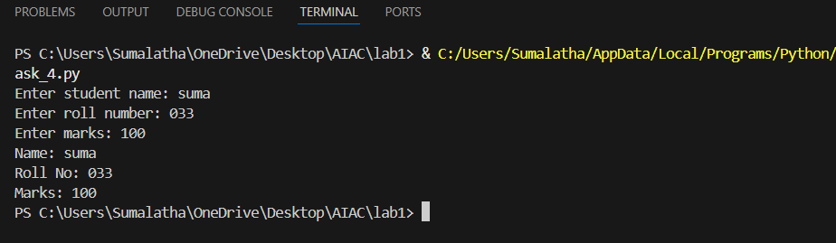

**Task Description #5  
•** Ask GitHub Copilot to generate a Python function that takes a string as input and returns the frequency of each word.

Prompt:

Write a python function that takes input as string from the user and returns the frequency of each word as the output.

Code:

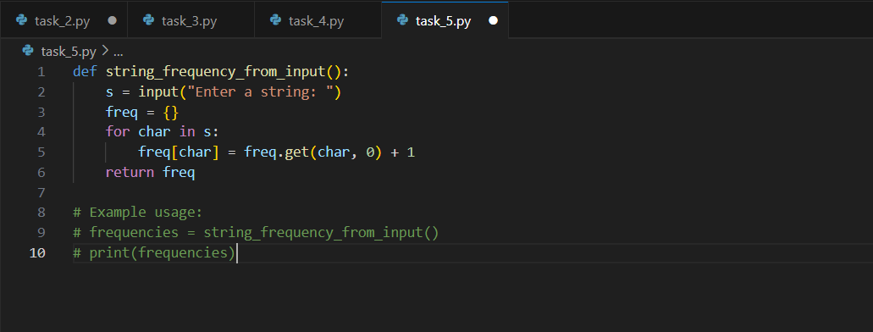

Output:

